Project Design Phase-II
Technology Stack (Architecture & Stack)
Date | 06-07-2026
Team ID
Project Name | SB Stocks - Stock Trading Application (MERN)
Maximum Marks | 4 Marks

Technical Architecture:
The diagram below represents the technical architecture of SB Stocks, along with the component and characteristic details in Table-1 & Table-2.
SB Stocks - MERN Stack Architecture (Frontend ⇔ Backend ⇔ Database)
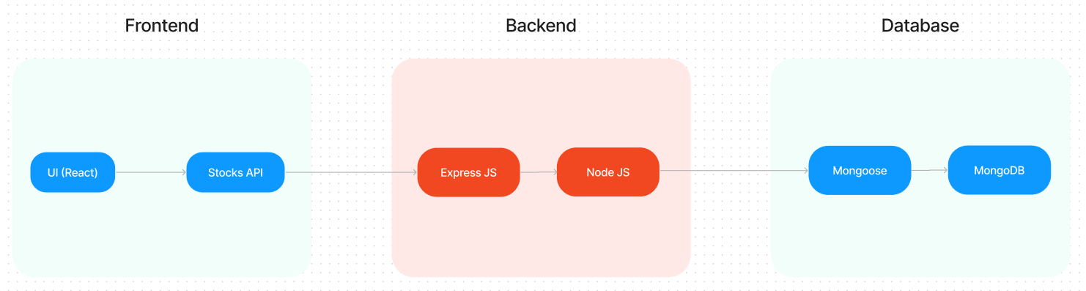

Table-1 : Components & Technologies:

S.No. | Component | Description | Technology
1. | User Interface | Web UI for browsing stock listings, executing trades, managing portfolio, and admin dashboard. | HTML, CSS, JavaScript, React.js
2. | Application Logic-1 | User registration, login, and session/authentication logic. | Node.js, Express.js, JWT
3. | Application Logic-2 | Stock order (buy/sell) processing and portfolio value calculation logic. | Node.js, Express.js (Order & Transaction Controllers)
4. | Application Logic-3 | Admin management logic - monitoring users, orders, and stock listings. | Node.js, Express.js (Admin Controllers & Middleware)
5. | Database | Stores Users, Stocks, Orders, and Transactions data. | MongoDB (NoSQL) with Mongoose ODM
6. | Cloud Database | Cloud-hosted database service for deployment. | MongoDB Atlas
7. | File Storage | Storage for static assets and frontend build files. | Local Filesystem / Cloud Storage (deployment)
8. | External API-1 | Fetching real-time and historical US stock market data. | Stock Market Data API (e.g., Alpha Vantage / Finnhub)
9. | External API-2 | Sending registration confirmation and account emails. | Nodemailer / SMTP Email API
10. | Machine Learning Model | Not used in the current scope of the application. | N/A
11. | Infrastructure (Server / Cloud) | Application Deployment on Local System / Cloud.  Local Server Configuration: Node.js + Express server on localhost:8000, React dev server on localhost:5173.  Cloud Server Configuration: Deployable on Render / Heroku / AWS with MongoDB Atlas. | Local, Render / Heroku / AWS

Table-2: Application Characteristics:

S.No. | Characteristics | Description | Technology
1. | Open-Source Frameworks | React.js, Node.js, Express.js, and Mongoose - all open-source frameworks used across the MERN stack. | React.js, Express.js, Node.js, Mongoose
2. | Security Implementations | Passwords are hashed before storage; authentication uses JWT tokens; protected API routes are guarded by auth middleware. | bcrypt, JWT, Middleware-based Access Control
3. | Scalable Architecture | The application follows a modular 3-tier MVC (Model-View-Controller) architecture, separating models, controllers, and routes so new features can be added with minimal rework. | MVC Architecture (3-tier: React / Express / MongoDB)
4. | Availability | The stateless REST API backend can be deployed across multiple instances / behind a load balancer for high uptime. | Node.js / Express stateless REST APIs
5. | Performance | Efficient MongoDB queries and indexed collections combined with React's component-based rendering keep API responses and UI updates fast. | MongoDB Indexing, React.js

References:
https://c4model.com/
https://www.mongodb.com/mern-stack
https://www.ibm.com/cloud/architecture
https://aws.amazon.com/architecture

